BALANCING BACKGROUND AND TASK LIGHTING UNDER DYNAMIC OCCUPANCY: A SIMULATION-BASED OPTIMIZATION STUDY

Kefan Chen^{1,}*, Guanli Feng², Yu Qian Ang¹, Adrian Chong¹

¹College of Design and Engineering, National University of Singapore, Singapore.
²Department of Architecture, National University of Singapore, Singapore

ABSTRACT
Traditional building design is typically based on full-load occupancy, whereas actual workplace occupancy varies in both density and spatial distribution. This mismatch can cause unnecessary illumination in underused spaces. This study proposes a Balanced Light Control Framework that coordinates three ceiling-light zones and 24 workstation task lights while maintaining visual-comfort requirements. A three-dimensional model of a Singapore office laboratory was evaluated under Clear, Overcast, and Night conditions and occupancy counts from 1 to 15. Five matched seating distributions were generated at each count, producing 225 scenarios. A penalty-based genetic algorithm was compared with an idealized zonal PIR ceiling-only baseline and an occupancy-triggered rule-based hybrid baseline. Scenario-mean power for the GA-derived hybrid solutions was 17.44 W under Clear, 93.01 W under Overcast, and 236.10 W at Night. Relative to zonal PIR, these values were 76.9%, 62.0%, and 46.8% lower, respectively. Relative to rule-based hybrid control, the GA-derived solutions were 22.5% lower under Overcast and 25.0% lower at Night, but 44.6% higher under Clear. The results demonstrate a daylight-dependent transition from task-light-dominant to background-light-dominant operation, while the Clear-sky exception shows that optimization does not automatically outperform a well-specified fixed rule. Seat location also produced substantial within-count variation, supporting the use of spatial occupancy information in lighting control.

KEYWORDS
Occupancy-centric lighting optimization, Task lighting, Energy saving, Genetic algorithm, Visual comfort

INTRODUCTION
Lighting systems in offices are often designed and commissioned for nominal or full occupancy, although actual use varies over time and across workstations. Controls based only on schedules or aggregate occupant counts may therefore illuminate areas that are unoccupied or already receive sufficient daylight. Room-level occupancy datasets further demonstrate that office use is temporally variable, motivating controls that respond to actual space use (Tekler et al. 2022). If lighting systems fail to flexibly adjust to occupancy variations, issues like “localized over-illumination” or “energy waste” readily occur.
Centralized ceiling lighting and personalized task lighting operate at different spatial scales. Ceiling luminaires provide general illumination and uniformity, whereas task lights deliver illuminance close to individual workplanes, giving occupants freedom to adjust local environments (De Korte et al. 2015). Existing research often focuses on optimizing individual systems, such as adjusting central lighting based on occupant counts (Lesina Debiasi et al. 2020) or evaluating personal light usage preferences and effectiveness (Papinutto et al. 2021). However, few studies explore joint optimization strategies for both systems under dynamic occupancy conditions at an integrated level. This results in potential imbalances between energy consumption and comfort in actual building lighting operations. Meanwhile, the minimum-power division between background and task lighting remains sensitive to daylight, occupancy density, and the locations of occupied seats. These factors are rarely examined together in a controlled scenario matrix.

This study asks: how should ceiling and task-light levels be coordinated under changing daylight and occupancy patterns to minimize lighting power while satisfying visual-comfort constraints? A Balanced Light Control Framework is evaluated in a simulated open-plan office. The contribution is threefold: (1) a joint representation of three ceiling-light zones and 24 task lights; (2) a penalty-based optimization formulation incorporating illuminance and uniformity; and (3) a matched comparison of GA-derived settings, zonal PIR ceiling-only control, and occupancy-triggered rule-based hybrid control across 225 lighting-occupancy-seating scenarios. The emphasis is a case-specific comparison rather than a deployed real-time controller.

METHODOLOGY
Optimization workflow
The complete workflow is summarized in Figure 1. Environmental inputs comprised the three-dimensional office model, one of three sky conditions, and a randomly generated occupancy distribution containing 1–15 occupants (Figure 1(a)), as proved that only 0.3% percentage of recorded time there were over 15 occupants (Tekler et al. 2022). These inputs were paired with a 27-variable lighting-control vector comprising the discrete output levels of three ceiling-light zones and 24 workstation task lights (Figure 1(b)).

For each candidate vector, ClimateStudio calculated task-area and surrounding-area illuminance and uniformity, while the ceiling- and task-light levels were converted to total lighting power. These quantities formed the visual-comfort constraints and power objective (Figure 1(c)). The penalty-based genetic algorithm iteratively updated the lighting vector and repeated the simulation until the lowest-fitness feasible solution was retained (Figure 1(d)). This solution defined the balanced ceiling light and task light configuration for the scenario (Figure 1(e)). Its power demand was then compared on a matched-case basis with the idealized zonal PIR ceiling-only and occupancy-triggered rule-based hybrid baselines (Figure 1(f)).

Case-study model and lighting systems
A three-dimensional model was constructed for a single open-plan office laboratory located within a larger building in Singapore, using the existing architectural geometry. Figure 2 identifies the simulated room within the host-building model; only this room, rather than the whole building, was included in the lighting simulations. The room contains 24 fixed workstations, each equipped with an independently adjustable task light. The background system is divided into three ceiling-light zones: seats 0–7, 8–15, and 16–23. ClimateStudio was used to calculate illuminance and uniformity for the occupied task areas and their surroundings.
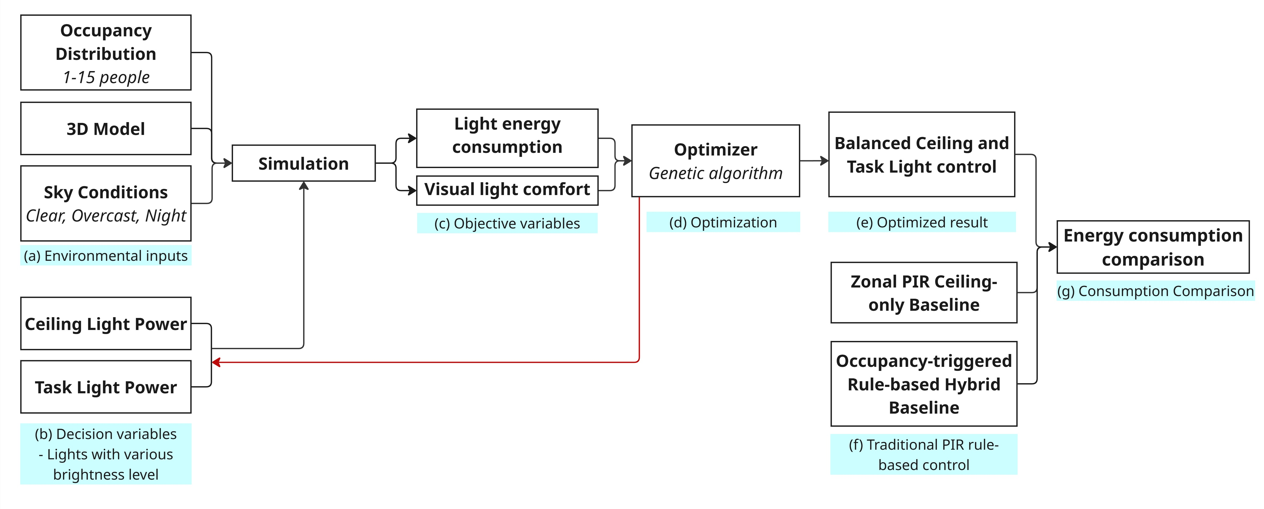
Figure 1. Workflow of the simulation-based lighting-control study

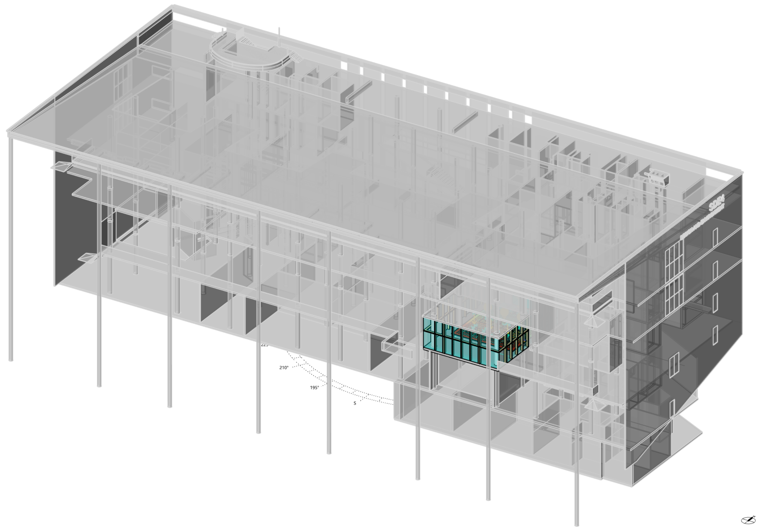
Figure 2. Location of the simulated office room within the host building

Scenario matrix
As shown in Table 1, the experiment considered three representative conditions labelled Clear, Overcast, and Night. Daylight simulations were referenced to Changi International Airport, Singapore. The three sky cases used the ClimateStudio sky identifier ‘Sky: [Changi.Intl.AP,SG,SGP 3.21.13.00]’, at13:00 on 21 March. Occupancy count ranged from 1 to 15. At each count, five unique seating distributions were randomly selected from the 24 workstations. The same 75 occupancy–seating patterns were evaluated under all three conditions, enabling matched comparisons and yielding 225 optimization scenarios.

Table 1. Experimental scenario matrix
Factor | Levels |  | Cases
Lighting condition | Clear, Overcast, Night |  | 3
Occupancy count | 1–15 occupants |  | 15
Seating distribution | Five patterns per count |  | 5
Total | Matched factorial matrix |  | 225
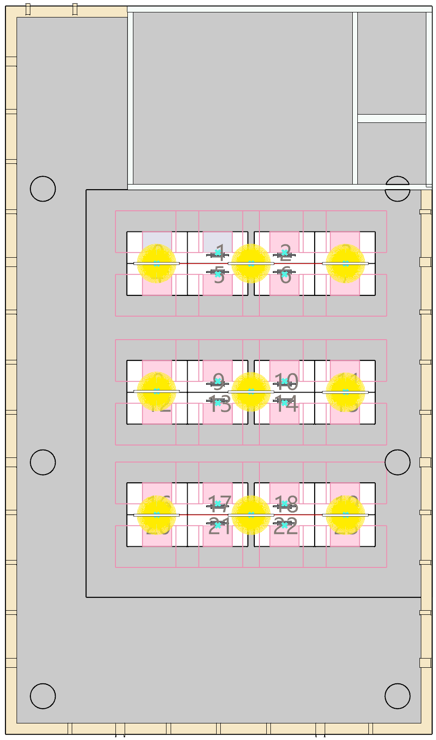 |  | 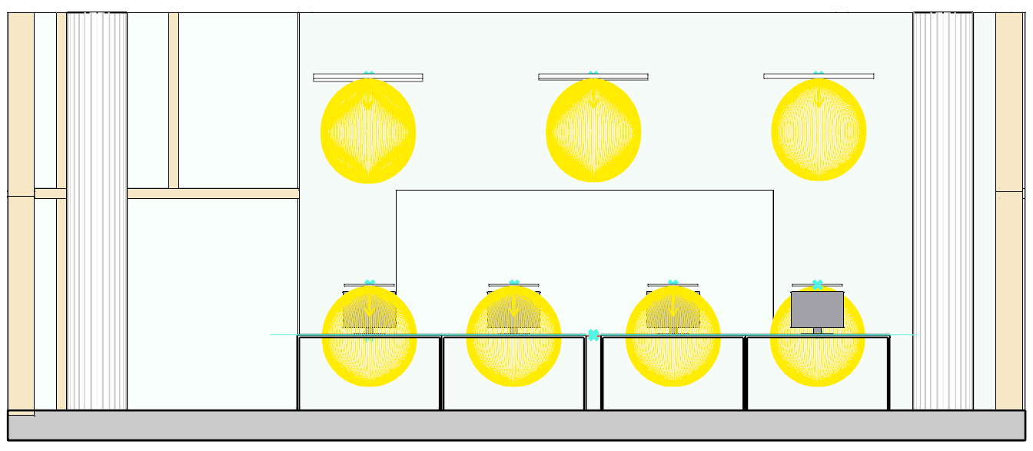
 |  | - Front View
 |  | 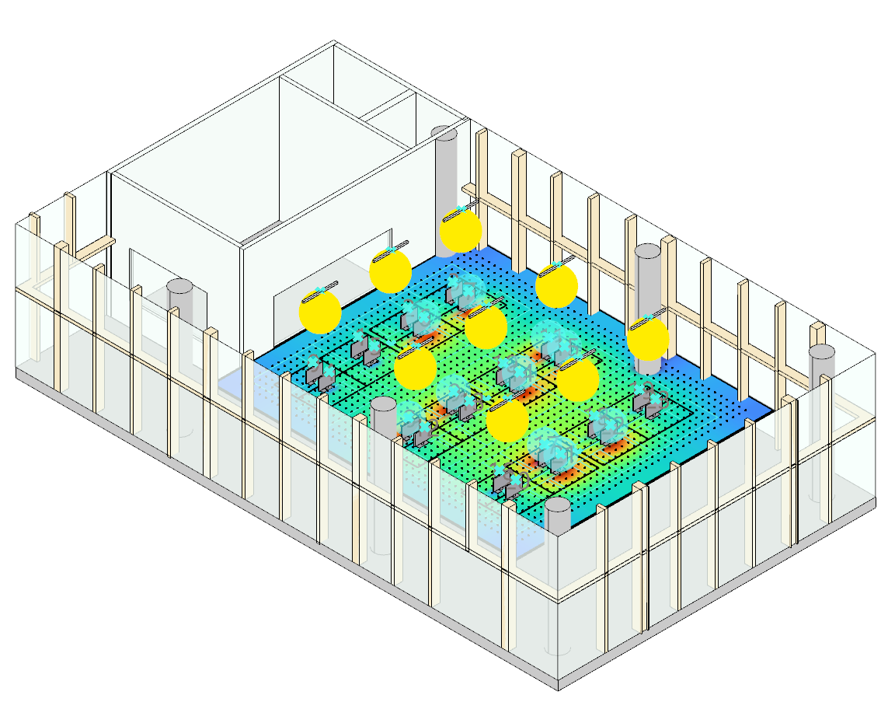
- Top View |  | - Perspective View
Figure 3. Room-scale simulation model, workstation layout, and lighting-system arrangement

Decision variables and lighting power
The control vector comprises discrete output levels for the three ceiling zones and 24 task lights. Task lights at unoccupied seats were constrained to remain off. The exported results indicate that each task-light level adds 1.5 W and each ceiling-zone level adds 13.2 W. Total lighting power was therefore calculated as:

P = 13.2 Σⱼ₌₁³ Lc,j + 1.5 Σᵢ₌₁²⁴ Lt,i .

This expression reproduced the reported power for all 225 exported solutions without error. Because the simulations represent discrete conditions without an assigned duration, the analysis reports electrical power (W), not energy consumption (kWh).

Rule-based comparison strategies
Two deterministic controls were evaluated using the same 225 occupied-seat lists. In the idealized zonal PIR ceiling-only baseline, task lights remained off and an empty ceiling zone was switched off. For an occupied zone, the ceiling level was the maximum seat-specific requirement among its occupants. The occupancy-triggered rule-based hybrid used the same maximum rule for each zone's ceiling component, while every occupied workstation received its own prescribed task-light level and every unoccupied task light remained off. Both comparisons therefore use known seat locations; the hybrid strategy assumes workstation-level occupancy triggering rather than a conventional zone-only PIR sensor.

For zonal PIR under Night, the two outer seat columns in every four-seat row required ceiling level 13 and the two middle columns level 11. Under Overcast, seat-level requirements were 0/3:10, 1/2:9, 4-6:8, 7:9, 8/11:8, 9/10:7, 12/15/16/19:5, 13/14/17/18:4, and 20-23:0. Under Clear, they were 0-3:6, 4-5:1, 6-7:2, 8-10:1, 11:2, and 12-23:0. For rule-based hybrid control, each pair (ceiling, task) was (8,3) at every occupied seat under Night. Under Overcast the pairs were 0-3:(5,4), 4-7:(4,4), 8-11:(3,3), 12-19:(0,3), and 20-23:(0,0); under Clear they were 0-3:(0,4), 4-11:(0,1), and 12-23:(0,0). These fixed levels were established for the stated visual requirements. Baseline power was then calculated with the same 13.2 W ceiling-zone and 1.5 W task-light level coefficients.

Visual-comfort constraints and objective function
Visual-comfort requirements were based on SS 531:2006. Occupied task areas were required to achieve at least 500 lux with uniformity Emin/Eavg ≥ 0.70; surrounding areas required at least 300 lux with uniformity ≥ 0.50. Violations were normalized and added to lighting power through a quadratic penalty function:

Fitness = P + λE1(vE1)² + λE0(vE0)² + λU1(vU1)² + λU2(vU2)².

Here, v represents the normalized violation of each illuminance or uniformity threshold and λ is its penalty coefficient. The penalties prioritize feasible lighting conditions before minimizing power. The final manuscript should report the numerical penalty coefficients and any sensitivity test used to confirm that infeasible low-power solutions were excluded.

Genetic-algorithm optimization
Figure 4 documents a representative seven-occupant case, linking the complete Galapagos optimization interface to its associated seating distribution and simulated illuminance field.

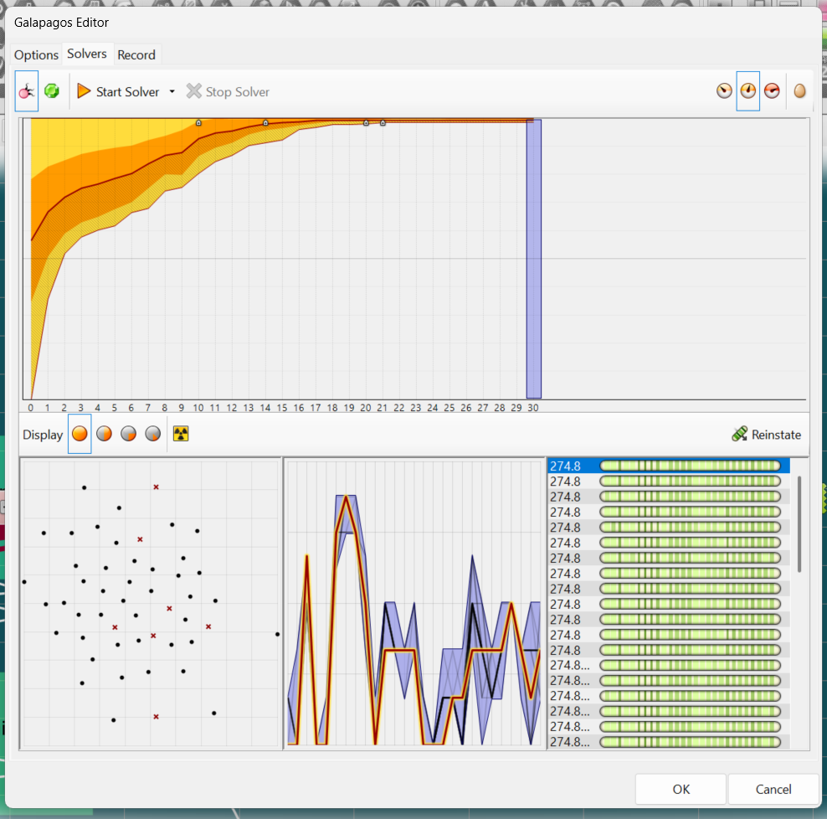 | 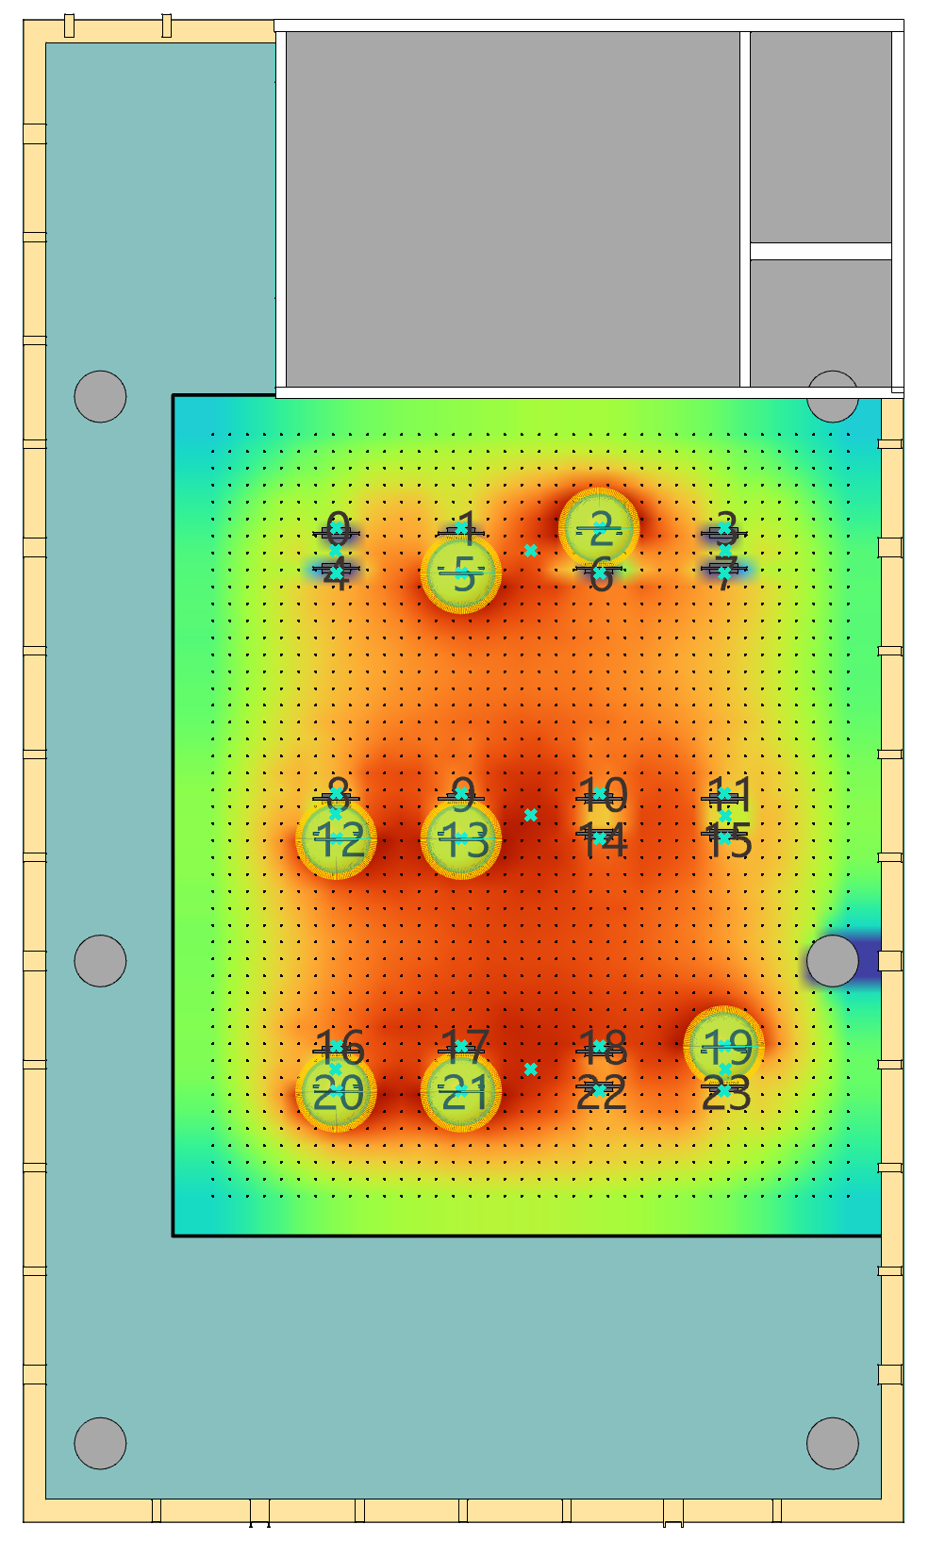
Figure 4. Representative seven-occupant optimization: (a) complete Galapagos interface; (b) corresponding occupant distribution and simulated illuminance field

Galapagos in Grasshopper was operated in minimization mode. For each scenario, the algorithm evolved combinations of the 27 discrete lighting variables. ClimateStudio and the associated calculation scripts evaluated task-area and surrounding-area illuminance, uniformity, and total power at each candidate solution. The retained output was the lowest-fitness configuration satisfying the encoded constraints. Population size, generation limit, convergence criterion, random seed, number of repeated runs, and software versions remain to be added for reproducibility.

RESULTS
Comparative power demand across strategies
Figure 5 compares the three strategies as occupancy increased. Each line is the mean of five matched seat distributions and each band is their observed minimum-maximum range. Across all 75 scenarios per condition, mean power for zonal PIR, rule-based hybrid, and GA-derived hybrid control was 75.50, 12.06, and 17.44 W under Clear; 244.46, 120.03, and 93.01 W under Overcast; and 443.52, 314.78, and 236.10 W at Night. Thus, GA-derived control reduced scenario-mean power relative to zonal PIR by 76.9%, 62.0%, and 46.8% for Clear, Overcast, and Night, respectively. Relative to rule-based hybrid control, it reduced mean power by 22.5% under Overcast and 25.0% at Night, but increased it by 44.6% under Clear.
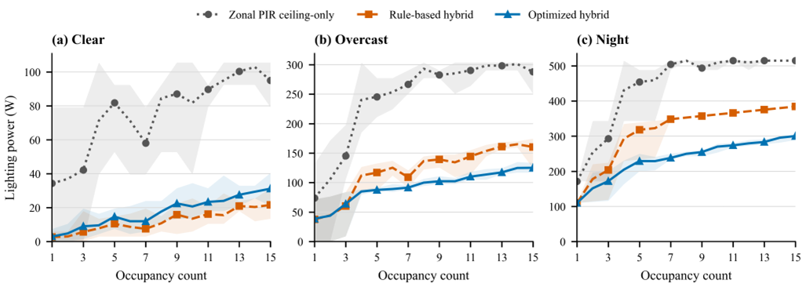
Figure 5. Lighting power versus occupancy for zonal PIR ceiling-only, rule-based hybrid, and GA-derived hybrid control under (a) Clear, (b) Overcast, and (c) Night conditions. Lines show the mean across five matched seat distributions at each occupancy count; shaded bands show the observed minimum-maximum range (n = 5 layouts). Panel y-axis ranges differ to preserve visibility.

Power allocation and paired strategy outcomes
The daylight-dependent difference was primarily associated with ceiling-light demand (Figure 6a). The Clear GA-derived and rule-based hybrid solutions used no ceiling lighting on average and required 17.44 and 12.06 W of task lighting, respectively. Under Overcast, GA-derived ceiling power was 61.07 W compared with 86.77 W for rule-based hybrid control; at Night the corresponding values were 194.48 and 278.78 W. Task-light power was similar under Overcast (31.94 versus 33.26 W) and was higher for the GA-derived strategy at Night (41.62 versus 36.00 W), but the ceiling reduction dominated total power. Ceiling lighting therefore accounted for 0.0%, 65.7%, and 82.4% of GA-derived power under Clear, Overcast, and Night, respectively.

Paired case comparisons reinforce the condition dependence. The GA-derived solution used less power than rule-based hybrid control in 1 of 75 Clear cases, 60 of 75 Overcast cases, and 69 of 75 Night cases; it used more power in 66, 3, and 0 cases, respectively, with the remaining cases tied. The negative Clear saving in Figure 6b is therefore systematic across the sampled layouts rather than being caused by a small number of outliers.
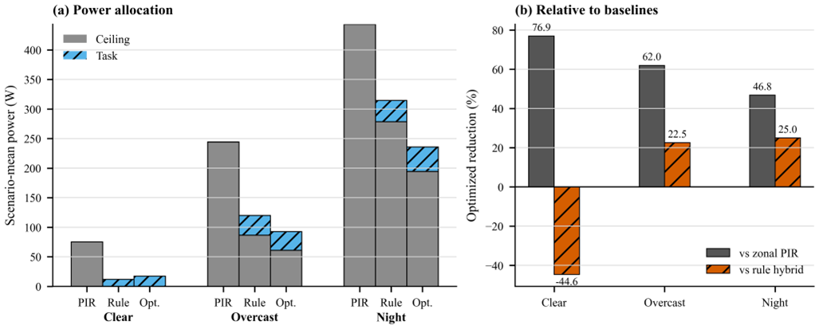
Figure 6. Strategy-level power allocation and comparative savings. (a) Scenario-mean ceiling and task-light power, averaged equally across 75 occupancy-layout cases per condition. (b) Percentage reduction in GA-derived hybrid mean power relative to the two rule-based baselines; negative values denote higher GA-derived power.

Occupancy and seating-pattern sensitivity
GA-derived mean power increased overall from one to 15 occupants, from 3.0 to 31.2 W under Clear, 38.8 to 125.1 W under Overcast, and 110.1 to 300.4 W at Night. The trajectories were not strictly monotonic because each occupancy count used different spatial layouts and activated different combinations of ceiling zones. Across occupancy counts, the mean within-count power range for the five layouts was 14.6 W under Clear, 24.8 W under Overcast, and 31.4 W at Night for the GA-derived strategy. The largest observed ranges were 21.0 W at ten occupants under Clear, 76.5 W at two occupants under Overcast, and 85.2 W at three occupants at Night. Seat location therefore remained influential even when occupant count and sky condition were fixed.

DISCUSSION
The comparison shows that the value of coordinated task and background lighting depends on daylight availability and on the reference controller. Relative to ceiling-only zonal PIR, the GA-derived strategy lowered scenario-mean power in all three conditions, with the largest relative reduction under Clear. Relative to the stronger rule-based hybrid baseline, however, additional optimization was beneficial only under Overcast and Night. In those conditions, the main mechanism was a lower ceiling-light contribution while task lights maintained local workplane requirements.

The Clear result is an important counterexample to an assumption that a genetic algorithm must outperform a fixed rule. The rule-based hybrid required only localized task lighting and was lower than the retained GA solution in 66 of 75 cases. If both strategies satisfy identical illuminance and uniformity constraints, this difference indicates that the present Galapagos runs should not be interpreted as strict global optima. Convergence, penalty weighting, discrete search resolution, and repeated-run variability should be examined. Accordingly, the results are described as GA-derived feasible solutions rather than a proven global performance bound.

The variation among seating patterns also has a direct sensing implication. A controller based only on total occupancy would assign identical settings to spatially different cases, although zone activation and daylight exposure can produce markedly different power demand. Practical implementation may therefore benefit from zonal location or workstation-level occupancy information. The idealized baselines used known occupied-seat IDs; real PIR sensors with only zone-level detection would provide less spatial information and may require more conservative settings.
Several limitations bound interpretation. The study represents one office geometry and three selected lighting conditions rather than annual daylight variation. Occupancy was limited to 15 of 24 workstations, with five random layouts per count; these layouts are design samples, so their min-max ranges are not statistical confidence intervals. The comfort model considered simulated illuminance and uniformity but not individual preference, glare, sensor uncertainty, control delay, or hardware dynamics. Scenario means weight every count and layout equally and should not be interpreted as annual energy use. Finally, repeated GA runs and an independent cross-check of comfort compliance for all retained baseline and optimized settings are needed for a reproducibility audit.

CONCLUSION AND IMPLICATIONS
This study evaluated coordinated control of three ceiling-light zones and 24 task lights across 225 matched lighting-occupancy-seating scenarios. Compared with idealized zonal PIR ceiling-only control, the GA-derived hybrid strategy reduced scenario-mean power by 76.9% under Clear, 62.0% under Overcast, and 46.8% at Night. Compared with occupancy-triggered rule-based hybrid control, it reduced mean power by 22.5% under Overcast and 25.0% at Night, primarily through lower ceiling demand, but used 44.6% more power under Clear. This exception demonstrates that a simple daylight-specific rule can outperform the retained GA solution and that optimization claims must be supported by convergence and feasibility checks. The substantial variation among layouts at the same occupancy count further supports spatially resolved occupancy sensing. Overall, the framework provides a reproducible case-study platform for comparing occupancy-centric lighting strategies, while annual simulations and implementation-level validation remain necessary before claiming operational energy savings.

REFERENCES
De Korte EM, Spiekman M, Hoes-van Oeffelen L, Van Der Zande B, Vissenberg G, Huiskes G, and Kuijt-Evers LFM. 2015. Personal environmental control: Effects of pre-set conditions for heating and lighting on personal settings, task performance and comfort experience. Building and Environment 86: 166–176. https://doi.org/10.1016/j.buildenv.2015.01.002.
Papinutto M, Colombo M, Golsouzidou M, Reutter K, Lalanne D, and Nembrini J. 2021. Towards the integration of personal task-lighting in an optimised balance between electric lighting and daylighting: A user-centred study of emotion, visual comfort, interaction and form-factor of task lights. Journal of Physics: Conference Series 2042: 012115. https://doi.org/10.1088/1742-6596/2042/1/012115.
Singapore Standards Council. 2006. SS 531:2006 Code of Practice for Lighting of Work Places, Part 1: Indoor Lighting. Singapore: SPRING Singapore.
Tekler ZD, Ono E, Peng Y, Zhan S, Lasternas B, and Chong A. 2022. ROBOD, room-level occupancy and building operation dataset. Building Simulation 15: 2127–2137. https://doi.org/10.1007/s12273-022-0925-9.

* Corresponding author email: E1583443@u.nus.edu

